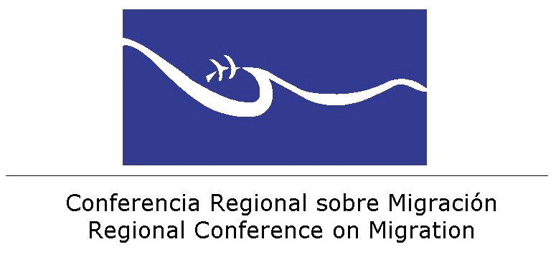

REGIONAL CONFERENCE ON MIGRATION (RCM)
Ad Hoc Group to Discuss, Analyse, and Establish Objectives relating to the Topic of Extra-continental Migration Flows in the Region

REPORT ON THE TOPICS

Based on the discussion of the topic “Identifying needs and brainstorming about extra-continental migration”, it was agreed to submit the following aspects at the upcoming meeting of RCGM:

- To exchange information about the identification of profiles of irregular migrants, including potential refugees or victims of migrant smuggling and trafficking, as well as potential traffickers and migrant smugglers, with the objective of generating migration intelligence, using the questionnaire for the identification of profiles that is currently being developed by IOM and UNHCR.

NOTE: The Technical Secretariat is expecting to receive the proposal by IOM and UNHCR in order to disseminate it among Member States for evaluation. IOM will be requested to develop profiles relating to trafficking and migrant smuggling networks. Once these instruments have been approved, an implementation proposal will be developed by the Liaison Officer Network to Combat Migrant Smuggling and Trafficking of RCGM.

- To establish a consultation mechanism to exchange information with the aim of learning if refugee status applicants have previously applied for refugee status in another country in the region.

In this regard, UNHCR has agreed to consider the request to share information from its internal data base, respecting the principle of confidentiality.

El Salvador will develop a proposal – to be shared with the Ad Hoc Group – on what type of information could be exchanged and will submit the proposal at the upcoming RCGM meeting.

- In regard to irregular extra-continental migrants, it was agreed to propose to RCGM the establishment of a protocol to determine the needs of these persons, including travel documents and securing funds for a safe return.

Note: In this regard, the Technical Secretariat will share the document “Mechanism for the return of extra-regional migrants that, having entered the region in a regular manner, are intercepted in an irregular situation in a country other than the country of entry” and will investigate the status and analyse this instrument with the OCAM Technical Secretariat.

The Technical Secretariat was requested to develop a matrix showing the visa categories of Member States of RCM for extra-continental nationalities that affect the region the most, with the aim of reviewing, analysing, and developing potential regional policies within RCGM.

- The Ad Hoc Group will submit best practices relating to migration management of extra-continental migrants to RCGM, with the objective of strengthening immigration controls in countries in the region.

Note: The Technical Secretariat will collect and systematize all relevant information about migration management.

Based on the discussion of the topic “Collecting information for statistical purposes: How can data collection be improved?” the following actions were approved:

- To prepare a table for each country to state what information is available, and for which years, for each one of the 10 items proposed in the matrix, and another table showing for which of these data an individual data base is available, and in what format. The Technical Secretariat will be in charge of developing the tables.

- To make adjustments to the matrix that was originally submitted, including recommendations by countries and UNHCR, and to disseminate this new version of the matrix as well. This task will be carried out by Mexico.

- To request that the TS study the possibilities of future collaboration with SIEMMES (Sistema de Integración Estadística sobre Migración en Mesoamérica).

To submit advances relating to statistical data collection on extra-continental migration flows to RCGM.

