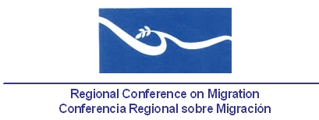

REPORT

Attendance of the Technical Secretariat’s Coordinator to the Third Meeting “The migration processes in Mexico and Central America: Diagnosis and regional proposals”, organized by the Instituto Tecnológico Autónomo de México, ITAM.

Guatemala City, Guatemala

October 1- 2, 2012

Participants

Academics, civil society organizations, IOM and delegates from governmental institutions from Belize, Costa Rica, El Salvador, Guatemala, Honduras, Mexico and the United States.

Report

The objective of the meeting and the general one of the project leaded by ITAM is to generate collective reflection periods which grant a privilege to:

- a regional vision of the migration phenomenon, the challenges implied and the possible solutions;
- a truthful dialogue, able to build trust among participants.

The plan is that these dialogue periods may provide diagnosis and concrete recommendations of public policy consensus.

The meeting was divided in three parts: the first consisted on two work rounds, guided by some presentations on migration, infrastructure and Development and safe borders topics. In this first part, only academics and organizations from the civil society were present.

The second part consisted of a dinner with the participation of governmental representatives. People were divided in four tables/groups to argue about four source-of-discussion questions:

- What is required to move to action in the Mexico/Guatemala/Belize border?
- What can Central America do to move towards shared responsibility?
- What role does extra-regional cooperation play regarding the border and migration discussion?
- How can we advance towards a regional vision?

The third part consisted of a meeting with governmental delegates where the main conclusions from the previous day were presented and comments on these specific topics were made:

- Migrants in transit
- Migrant protection practices
- Corruption and impunity
- What kind of institutional framework should be established in the region?

It is important to highlight that the participation of the TS was just as an observer. During dinner with delegates, the TS helped with the report of topic 4 (How can we advance towards a regional vision?). The objective to invite the RCM TS was to share with the Member Countries the conclusions, thoughts, proposals and recommendations from this meeting.

