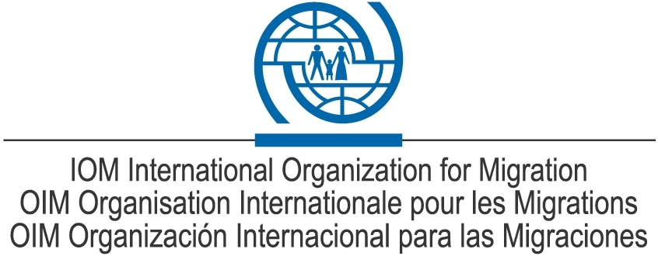

Proposed amendments to the agreement for the operation Fund of the Regional Conference on migration (RCM) to assist Intrarregional Migrants in High Vulnerability Situation (FAVM-RCM) - most relevant aspects

Topics | Aspects to clarify | Factors to Consider
1. Related expenses with the participation of the Government escorts. | 1.1 Should be or not to cover the costs of Government escorts of a vulnerable migrant with resources from the Fund?  1.2 If support of Government escorts, has been authorized. What number of escorts can be supported by the Fund? | 1.1. The maximum amount set for each return is 1000 USD (all inclusive) according to the agreement.  1.2. In the particular case of escorts for unaccompanied NNA returns, sometimes these are carried out with the assistance of two escorts, generally, immigration and child protection authorities.
2. Categories of vulnerable migrants who can benefit from the Fund. | 2.1. Victims of trafficking. Not included in the original agreement.  2.2. Victims of crimes such as kidnapping. Not included in the original agreement.  2.3. Victims of domestic violence. Not Included in the original agreement. | 2.1 These categories of vulnerable migrants are each day more common in the region but are not foreseen in the categories originally raised in the Fund.  2.2. Nowadays, when a migrant of these categories is asking support from the Fund, it is considered an exceptional case, which should be assessed differently and TS must consulted case by case in order to take a decision. This takes more time.
3. Authorization process for the use of Fund resources. | 3.1 Defining a specific process to be followed for the evaluation and approval of cases of migrants who are seeking support from the Fund but which are not part of the original categories of migrants defined in the Fund.  3.2 Simplifying the approval process in order to make it more expeditious, the use of the Fund. | 3.1. Nowadays there is no formal procedure to follow approved by RCM countries.  3.2. The original agreement RCM-IOM foresees the approval of all cases either with consent of the PPT or TS, procedure has been only delegated to IOM for time reasons, but this has not been formalized in any instrument. It should be deemed by the implications that it would have to respond quickly to requests.
Process to inform the consular authorities | 4.1 The IOM must or must not send information to authorities of the country of origin of the migrant about each return, for which the Fund is used prior to the return, is carried out?  4.2 What specific authority and how far in advance should be sent this information? | 4.1 The procedure established in the RCM-IOM agreement, to date does not envisage anything about these two topics.
5. Search for additional funds to supplement the Fund. | 5.1 In recent years, IOM has been given the task of finding additional resourced to supplement the Fund. This was done without any formalized a request to IOM to do so on behalf of the CRM. | 5.1 1 It is complex for the IOM search resources for a fund belonging to Governments, unless it has a specific mandate to do so.

