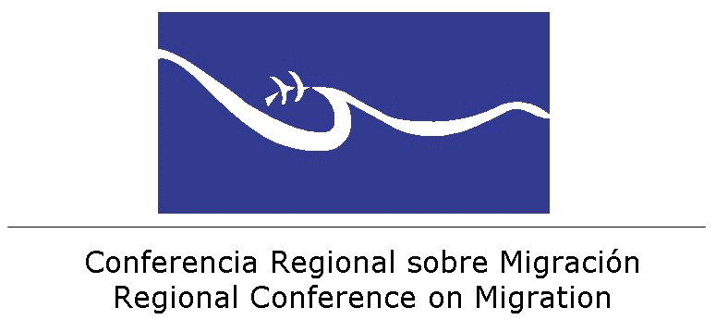

Report of the “Dialogue Meeting between Member States of RCM and some Countries of Origin of Irregular Extra-continental Migration Flows”

Contact information of Consular Offices for the identification of migrants.

COUNTRY | NAME | ADDRESS | PHONE | E-MAIL
Afghanistan | Mr. Abdul Hakim Atarud  Consular Affairs Counselor  Embassy of de Afghanistan | 2341 Wyoming Ave, NW  Washington, D.C. 20008 | Tel: 202-298-9123  Fax: 202-483-6488 | atarud@embassyofafghanistan.org  Web: www.embassyofafghanistan.org
Afghanistan | Ms. Monik Markus (Assistant) |  | Tel: 202-292-4297  Ext. 8009  Fax: 202-483-0326 | secretary@embassyofafghanistan.org
Bangladesh | Mr. Md. Shamsul Haque  Consular Minister  Embassy of Bangladesh | 3510 International Dr. N.W.  Washington, D.C. 20008 | Tel: 202-244-3571  Fax: 202-244-2771/7830 | shamsbd2001@yahoo.com  Web: www.bdembassyusa.org
China | Consular Section of the Embassy of the People´s Republic of China  in Mexico | Av. Río Magdalena 172  Col. Tizapán San Angel, 01090  México, D.F. | (55) 5616-4324/4309/4239  Ext. 101  Fax: 5616-5849 | consularchinaenmexico88@gmail.com  chinaemb_mx_admin@mfa.gov.cn  Web: http://www.embajadachina.org.mx/esp/
China | Consulate General of the People´s Republic of China in Tijuana  General Consul: Gao Shoujian | Baja California Norte, México:  Calle Lomas del Monte 1614 del Fraccto, Lomas de Agua Caliente 1ra.  Sección C.P. 22440, Tijuana | Tel: 0166-8167711  Fax: 219762
Eritrea | Embassy of Eritrea | 1708 New Hampshire Avenue, NW  Washington, DC 20009 | Tel: 202-319-1991  FAX: 202-319-1304 | embassyeritrea@embassyeritrea.org
Eritrea | Consular Services in the West Coast | 1708 New Hampshire Avenue, NW  Washington, DC 20009 | Tel: 202-384-1201  Fax: 202-319-1304 | embassyeritrea@embassyeritrea.org
Ethiopia | Mr. Dineka Kornma Nesredin  First Secretary | 3506 International Drive, N.W.  Washington, D.C. 20008 | Tel: 202-274-4568  Fax: 202 587 0197  Cel: 301-841-5892 | Dineka1976@yahoo.com  dineka@ethiopianembassy.org  Web:  www.ethiopianembassy.org
India | Mr. N.Balasubramaniyan  Counsellor and Director  Gurudev Tagore  Indian Cultural Centre | Anatole France 319  Col. Polanco 11550  México, D.F. | Tel: +52 55 5203-1117  +52 55 5531-7102  Fax: +52 55 5203-0619 | director_iccmex@prodigy.net.mx  icc_eoimex@prodigy.net.mx  Web:  www.indembassy.org
India | Embassy of India in Mexico | Musset 325  Col. Polanco 11550  México, D.F. | Tel: +52 55 5531-1050  +52 55 5531-1002  Fax: +52 55 5554-2349 | cons_eoimex@prodigy.net.mx
Nigeria | Embassy of Nigeria in Mexico | Diego Fernández de Córdoba "No. 125"  Col. Lomas Virreyes  Delegación Miguel Hidalgo  C.P. 11000 México, D. F. | Tel: 5245-1487  Fax: 5245-0105  5596 2008 | info@embassyofnigeria.com.mx
Nepal | Mr. Arjun Kant Mainali  Deputy Chief of Mission | 2131 Leroy Place N. W. Washington, D.C. 20008 | Tel: 202 667 4550 | info@nepalembassyusa.org
Sri Lanka | Mr. Don Ranjith Kaluthanthiri  Minister Consular  Embassy of Sri Lanka in Washington | 2148 Wyoming Avenue  Washington, D.C. 20008 | Tel: 202 355-1186  202 644 6858  Fax: 202 232-7181 | ministercons@slembassyusa.org  Web: www.slembassyusa.org

