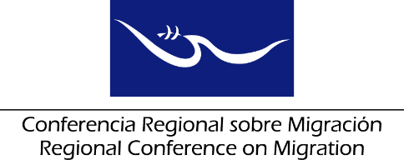 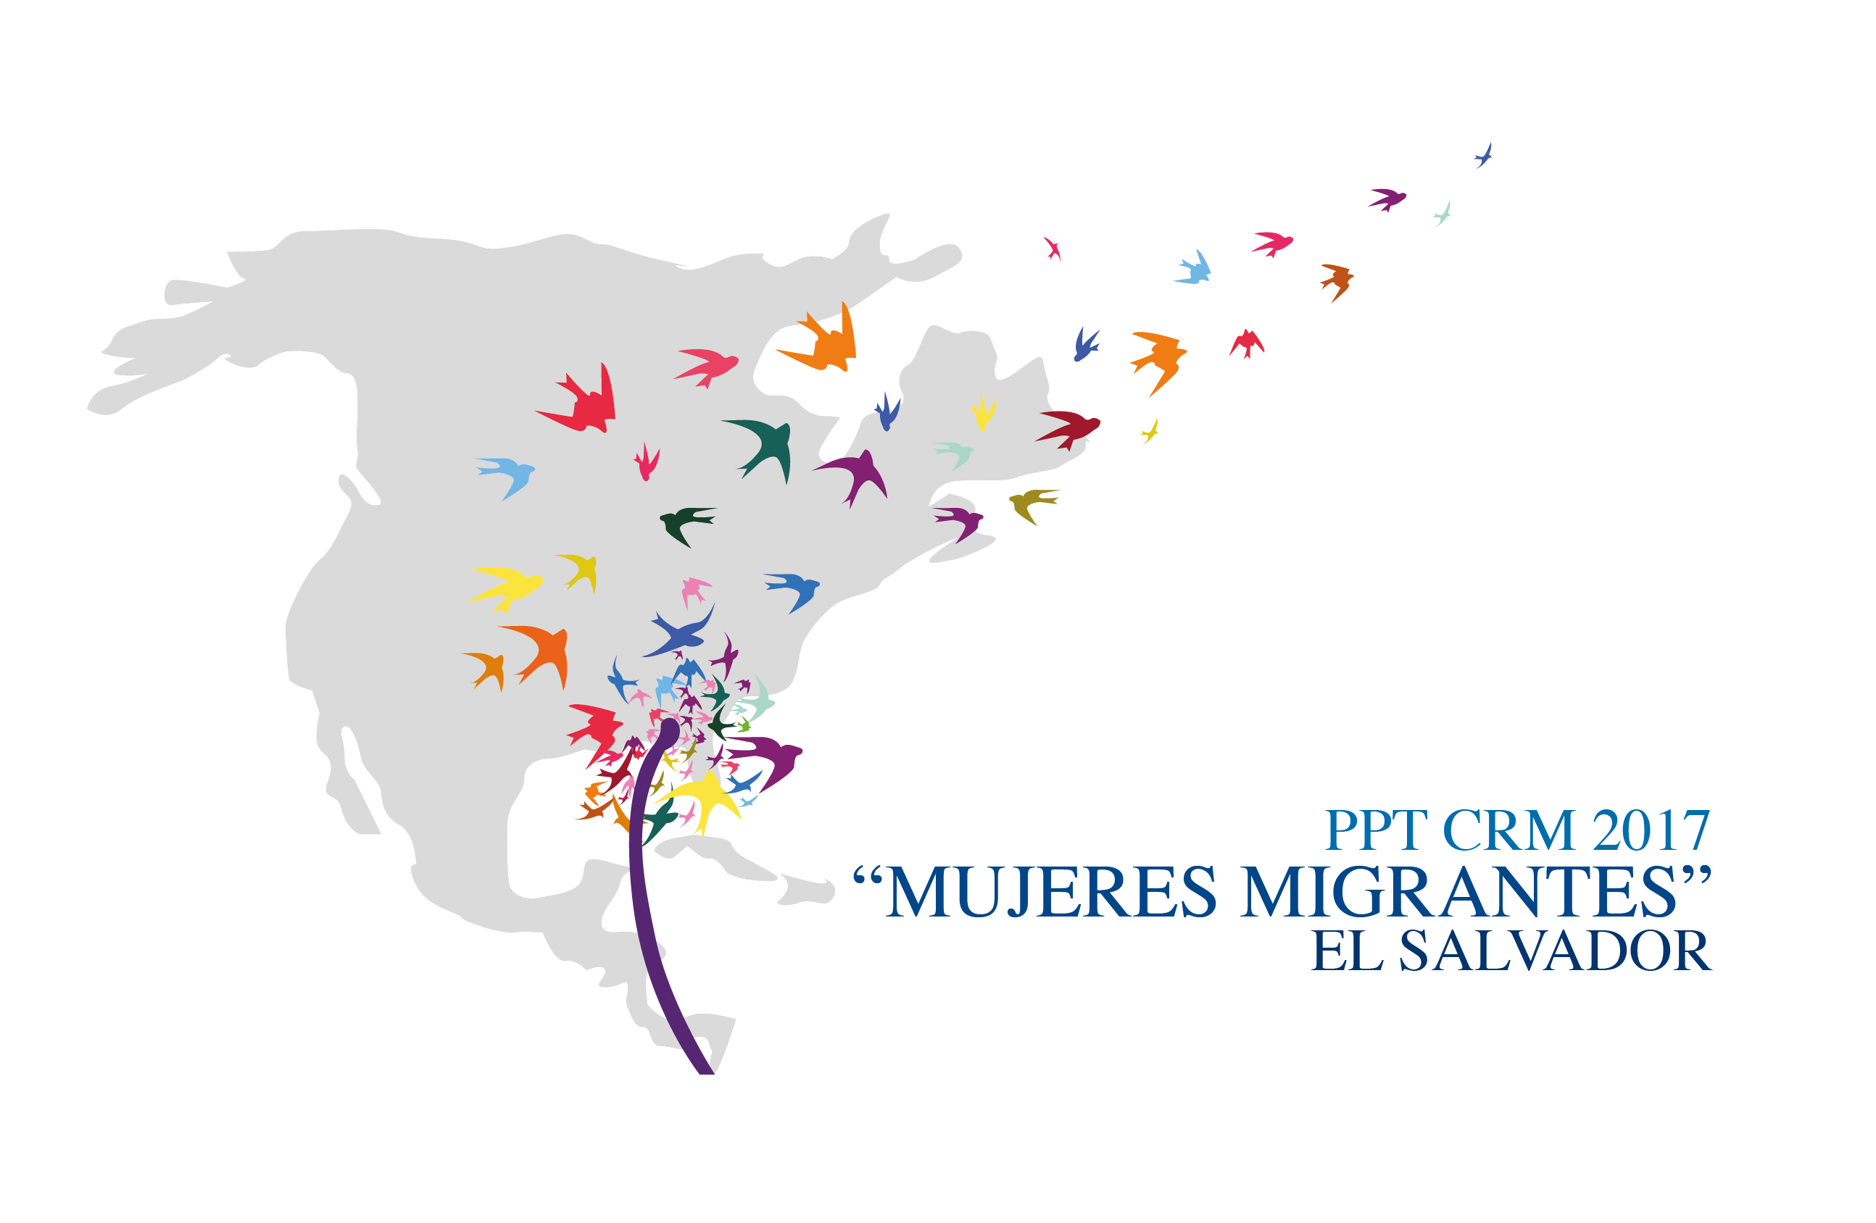

**Liaison Officers Network for the Protection of Migrant Girls, Boys and Adolescents**

**Regional Consultation Group on Migration (RCGM)**

**Ministry of Foreign Affairs**

**Room: Camilo Minero**

**San Salvador, El Salvador**

**20 June, 2017**

**PRELIMINARY AGENDA**

14:00 – 14:15 Approval of the agenda

***[Leads: PPT]***

14:15 – 15:30 Country reports on new efforts/best practices for the assistance and protection of migrant girls, boys and adolescents.

***[Lead: All delegations (5 minutes per delegation)]***

Note: you are kindly requested to restrain your presentation only to RECENT efforts/practices and to keep the length of your presentation to a maximum of five minutes.

15:30 – 15:45 Progress on the development of the Strategic Plan for the Liaison Officers Network for the Protection of Migrant Girls, Boys and Adolescents of the RCM for 2017 to 2022.

***[Leads: PPT]***

15:45 – 16:15 Dialogue with civil society organizations on recommendations to develop joint initiatives for the provision of assistance and protection of migrant girls, boys and adolescents.

***[Leads: RNCOM]***

16:15 – 16:30 Break

16:30 – 17:00 Open dialogue on the next steps to take for the implementation of the Strategic Plan of the Liaison Officers Network for the Protection of Migrant Girls, Boys and Adolescents of the RCM for 2017-2022.

***[Leads: PPT]***

17:00 – 18:00 Preparation of the Network’s report for the RCGM

***[Leads: PPT with support from the TS]***

18:00 Closure